Vibration Compensation
Hao Wu 20240222

The following is an introduction to the demo made for Tesla.

My experience comes from a product with embedded system to do vibration compensation (perturbation rejection), at ABB company, and the results have been judged very satisfying.

One sentence to summarize the algorithm at the beginning: Using signal ① to estimate signal ④, we utilize the Least Mean Squares (LMS) algorithm to evaluate the estimation error. When it converges to a minimum, the error becomes the signal we expect to obtain ③.

- Introduction to demo
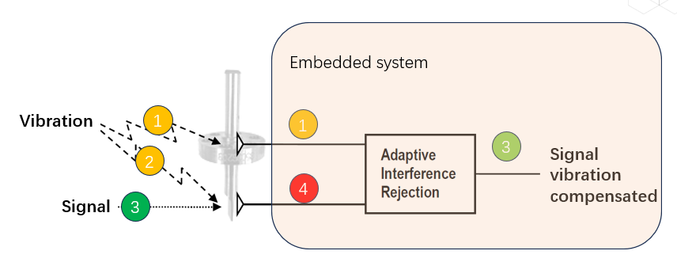
Fig 1 Architecture
Signal 1 and 4 is what we can get from data acquisition.
- ① is vibration signal or noise in other applications.
- ④ is a mixed signal containing both target signals ③ (dark green)and vibration ①, which coupled within in some way ②.
- Signal ③ (light green) is the calculation result, with purpose to reconstruct the target signals ③ (dark green

Below shows the simulation result:
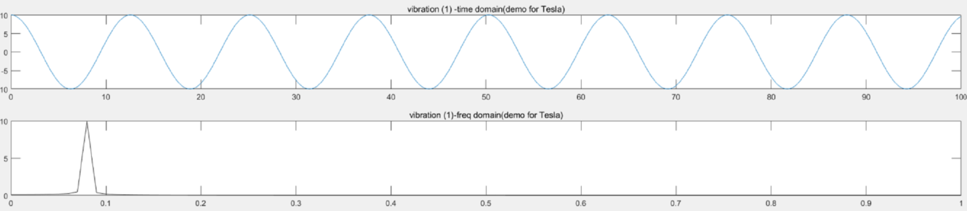
Fig 2 vibration ①

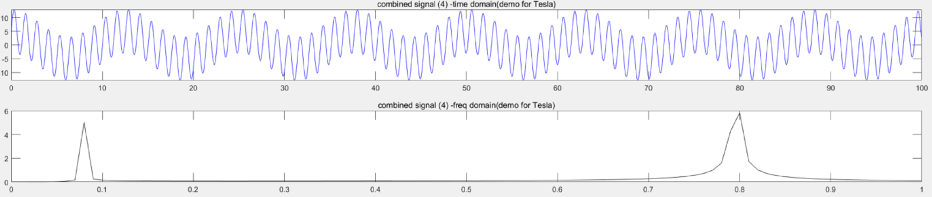
Fig 3 mixed ④

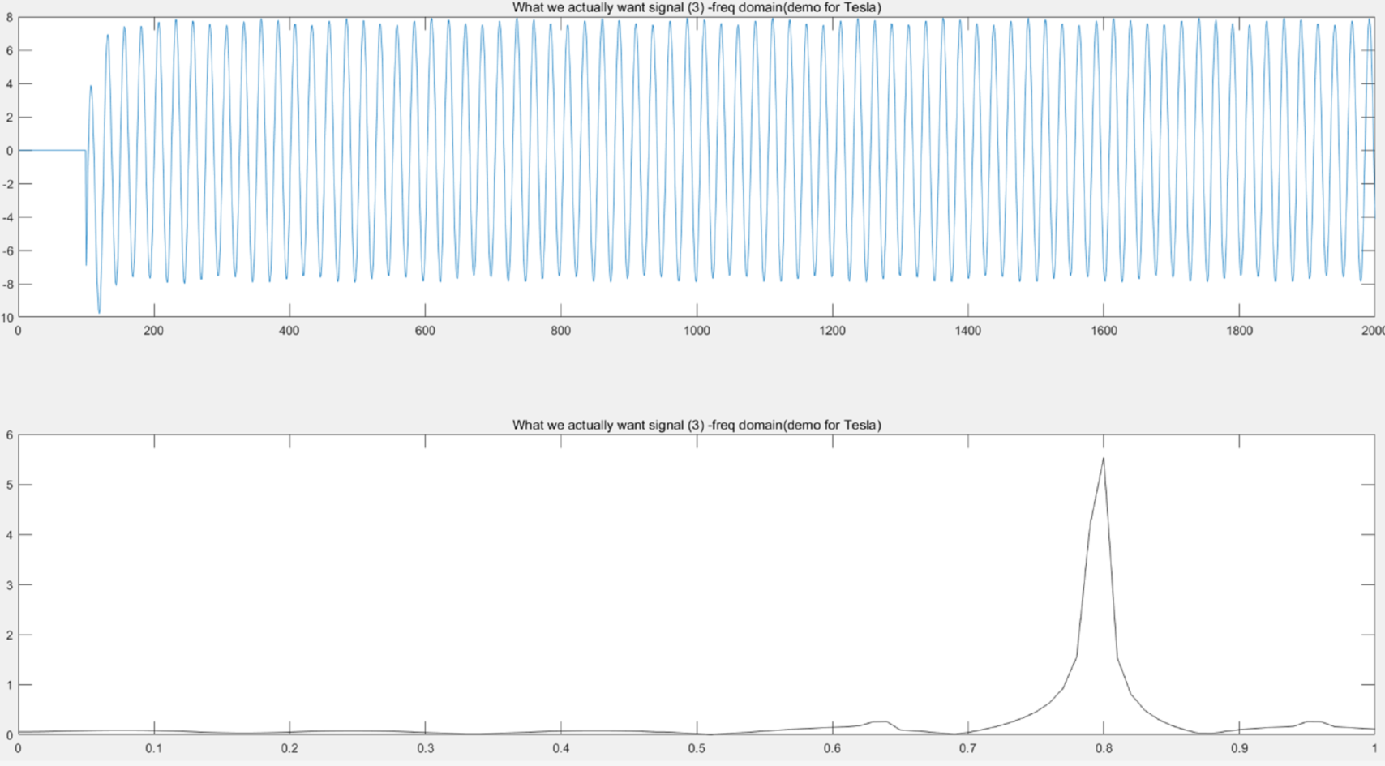
Fig 4 Calculation result ③ (light green)

As it is simulation, we know what the actual the target signals ③ (dark green) looks like in advance. It is as below:
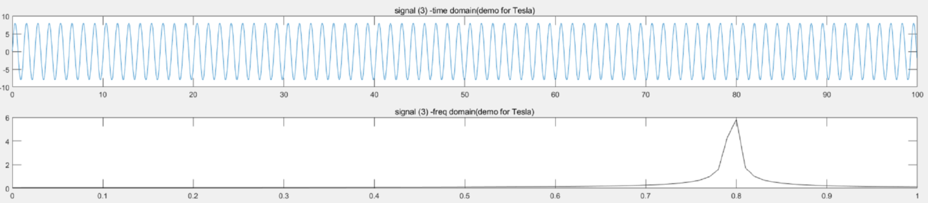
Fig 5 ③ (dark green)

Based the compassion between Fig4 and Fig5, we can conclude that we make the vibration compensation happens.

- Theory behind
The main task is to find how the vibration is coupled with the physical process while having quantitative information of it. More precisely we are concerned about finding the transformation that from the measured vibration ① will give us the interfering component ② so that we can discard its effect on the interesting signal.

So, obviously, the task is to find a equation to estimate the transformation of ②.
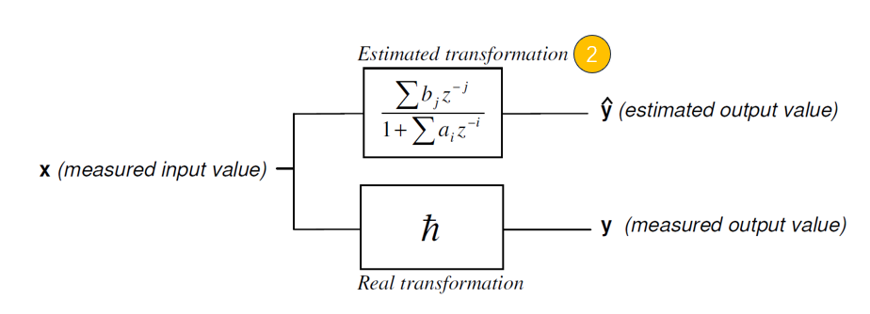
Fig 6 Transformation estimation
$$\hat{y}=-\sum_{i=p0}^{p1}{a_{i}\hat{y}\left(k-i\right)}+ \sum_{i=p0}^{p1}{b_{j}x\left(k-i\right)}$$
We use difference equation to describe the transformation estimation.
The next question will be how to do that, and with what criterion.

Toward target, we define an error as below equation, which is the difference between the measured value and estimated value:
$$ε\left(k\right)=y\left(k\right)-\hat{y}\left(k\right)$$

For the batch acquisition of N samples the assumption becomes the following:
$$\left[\begin{aligned}y\left(k0\right) \\ \\ … \\ \\ y\left(N\right)\end{aligned}\right]=\left[\begin{aligned}\begin{matrix}\hat{y}\left(k0-p0\right) & … & x\left(k0-q1\right) \\ & & \end{matrix} \\ \\ … \\ \\ \begin{matrix}\hat{y}\left(N-p0\right) & … & x\left(N-q1\right)\end{matrix}\end{aligned}\right]\left[\begin{aligned}-a_{p0} \\ \\ … \\ \\ b_{q1}\end{aligned}\right]+\left[\begin{aligned}ε\left(k0\right) \\ \\ … \\ \\ ε\left(N\right)\end{aligned}\right]$$

Here, we can summarize the writing:
$$y=AC+ε$$
Then error is as below
$$ε=y-AC$$
The very basic idea is to make the error to be convergent and smallest one. Here has some debate and discussion to select regression methods, such as Newton or LMS.
We select LMS, LMS (Least Mean Squares algorithm) is an adaptive filtering algorithm used to adjust the parameters of a filter based on the statistical characteristics of the input signal. This algorithm is widely applied in areas such as adaptive control, signal processing.

Then the squared error function is as below:
$$ε^{2}=({AC-y)}^{T}\left(AC-y\right)=C^{T}A^{T}AC-2y^{T}AC+y^{T}y$$
This has a minimum for:
$$2A^{T}AC-2A^{T}y=0$$
Then
$$C={{(A}^{T}A)}^{-1}A^{T}y$$
If the system is linear, the coefficients found should make the estimation fit the measured output y even under different vibrations conditions.

Here we introduce the first limitation that we assume that the system is linear.

If the system is linear, we know that the basic feature of linear system is that the signal of system is both additive and subtractive.
Then we can have below
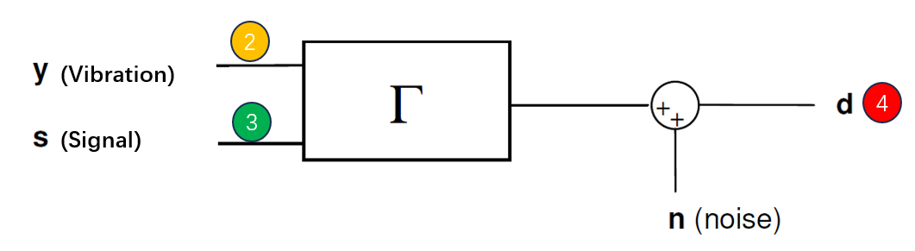
Fig 7 Linear system
Based on assumption of linear system, we have below
$$d=y+s+n=AC+ε$$
Go back to the LMS cost function
$$({ε)}^{2}={\left(d-AC\right)}^{2}={\left(y+s+n-AC\right)}^{2}=\left(\left(s+n\right)+\left(y-AC\right)\right)\left(\left(s+n\right)+\left(y-AC\right)\right)=$$
=${\left(s+n\right)}^{2}+ {\left(y-AC\right)}^{2}$
The optimization has no effect on the left term. The right term is the only one we can minimize if we refine C to make AC be as close as possible to y. Doing iterative operation and adjust parameters (a0…ai, b0…bi) with the dynamic error itself for the target to make the final error is the smallest one.

$$y≈\hat{y}=AC$$
Then
$$ε=s+n$$
After processing finished, you will be excited that the err itself is the signal with vibration compensated.
Here add one more graph to show the final estimation result of transformation of  for reference.
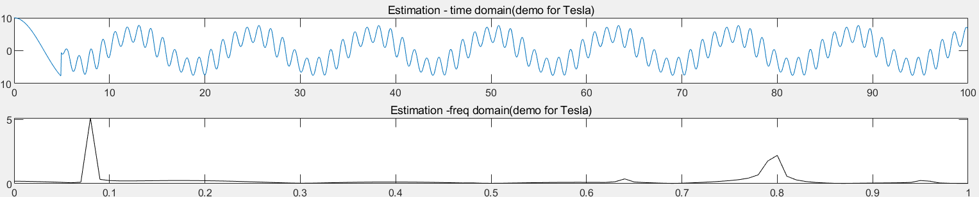
Fig 8 Transformation estimation result - 
Below graph shows comparison among three signals:
- Mixed signal (Input): ④ in red color
- Estimation signal (Output 1): in blue color as Fig 8
- Error = (Mixed signal- Estimation signal): in Yellow color, is ③ (light green), which is approximation of ③ (Dark green)
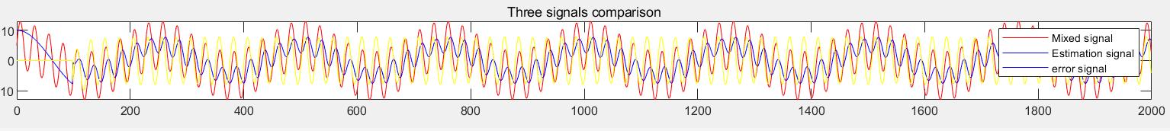
Fig 9 Signal Comparison

- Conclusion
One sentence to summarize the algorithm again: Using signal ① to estimate signal ④, we utilize the Least Mean Squares (LMS) algorithm to evaluate the estimation error. When it converges to a minimum, the error becomes the signal we expect to obtain ③.

This presentation demonstrates an ideal scenario with ideal signal and vibration signal quality. In the real physical world, applications are more complex than this. When dealing with complex applications, we conduct tests and calibrations. Additionally, there are conditions limiting error convergence, which is another topic.

